SQL ASSIGNMENT -14

ROLL NO-84016

Q1 Write a command that puts the following values, in their given order, into the salespeople table: city – San Jose, name – Blanco, comm – NULL, cnum– 1100.
Ans.
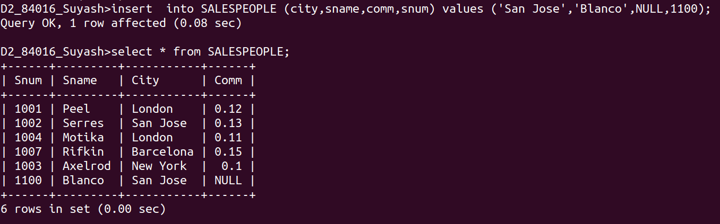

Q2.Write a command that removes all orders from customer Clemens from the Orders table.
Ans.
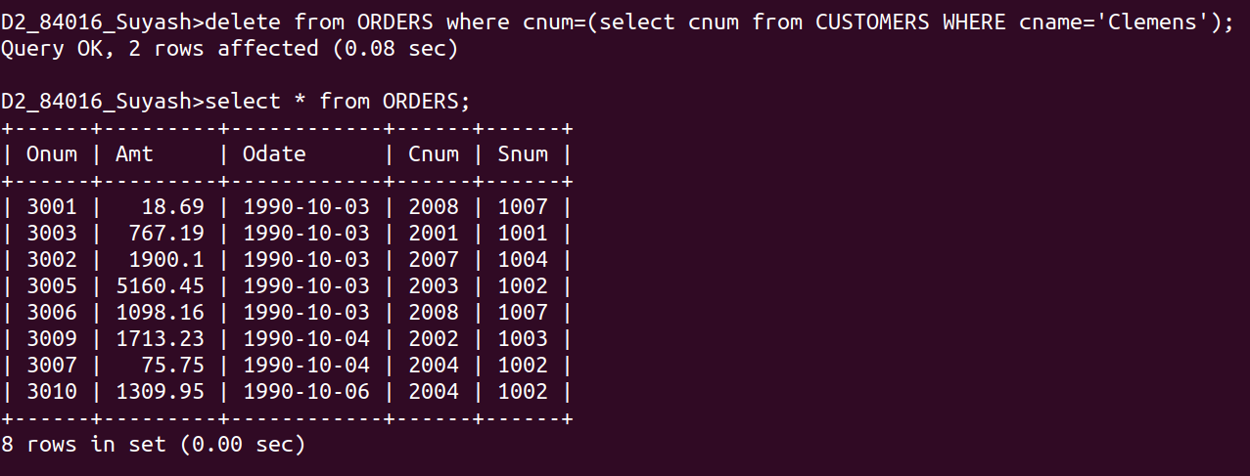

Q3.Write a command that increases the rating of all customers in Rome by 100.
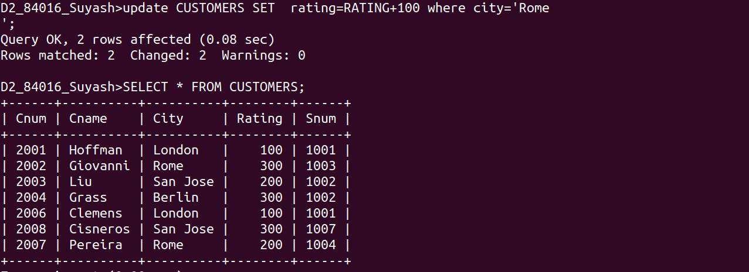
Ans.

Q4.Salesperson Serres has left the company.Assign her customers to Motika.
Ans.
